CHAMPAIGN PARKING ENFORCEMENT

Introduction
The Champaign Public Works Department is the hub for numerous public development divisions. The Parking Programs, a specialized division of the Champaign Public Works Department, manages city-owned parking spaces including 1,900 permit spaces and 2,014 meter spaces throughout the Downtown, East Side and University District Areas.
The Champaign Parking Enforcement (Parking Enforcement), a division of Parking Programs enables the city’s parking system to function efficiently and ensures turnover of parking. The Parking Enforcement division is run by one supervisor, Shirl Johnson. Johnson oversees ten employees: two accounting clerks, five parking enforcement officers, one meter maintenance worker and one grounds maintenance worker. A sixth parking enforcement officer, higher in rank than the others, acts as an assistant to Johnson. See Exhibit 1 for an organizational hierarchy map of Parking Enforcement.

Parking Enforcement
Parking Enforcement is responsible for enforcement, collection, permit parking and maintenance of the parking system infrastructure through the allocation of revenues generated from parking tickets and meters.
Parking meters help to regulate the flow of vehicles in high traffic areas and to ensure parking availability for all motorists. For example, the parking meters that are located in front of businesses in downtown Champaign have a time limit. This deters motorists from parking in one spot for an entire day, which would reduce the availability of parking spots for other motorists. Parking enforcement officers patrol the city, making sure that vehicle owners are paying the meters and following regulations.
Officers enforce the meters and lots Monday through Friday from 8 a.m. to 9 p.m. in Downtown and 7 a.m. to 5 p.m. in East Side. In the University District, where the primary flow of traffic occurs, officers enforce meters and lots Monday through Saturday from 7:00 a.m. to 9:00 p.m.
Johnson assigns an enforcement officer to each of six zones in the Champaign area. The officer patrols this zone searching for motorists who are in violation of parking procedures and regulations. Specifically, the officers are looking for parking meters that have expired or vehicles parked in one spot for more than the allowed time. Additionally, officers monitor the length of time people are in a parking spot by occasionally selecting a city block and entering in all of the licenses of the vehicles parked there. If the vehicles remain after the allowed time, the enforcement officer tickets those cars. Officers also monitor permit lots and cite violators.
If an officer finds a motorist in violation of the parking regulations, he/she issues a citation. The officer enters the information about the violation and the vehicle in violation into a handheld device. The officer prints the ticket on-site and places it in an envelope on the windshield. This informs the driver that he or she was in violation and must pay. At the end of the day, each officer downloads the information from the handheld device to a central computer. This computer keeps track of outstanding citations.
Administration
Once the information from the handheld devices is downloaded into the central computer system, the accounting clerks take care of all processes. The accounting clerks have many duties to balance: keeping track of downloads, manually updating violator information, mailing notifications, collecting payments and keeping books for the division. The central computer keeps track of how many tickets are outstanding; however, the clerk runs the main system and writes letters to violators with outstanding tickets. When a violator leaves a ticket unpaid, the clerk sends a letter to the address of the registered car owner. The clerk informs the Police Department to place a boot on the motorist’s car if a certain number of tickets has gone unpaid.
Violators can pay tickets online, through the mail, in person, or by phone. The recent addition of the online payment option has nearly doubled collection rates. Currently, the clerks collect an average of $300 a week in parking ticket fines. If a violator pays in person or by mail, the accounting clerk enters the necessary information into the computer system. The receipt of payment clears the violation from the driver’s record. If the driver pays online, the computer system automatically removes the violation without the assistance of the accounting clerk.
The clerks keep all cash received in a cashbox. The cashbox is kept in a locked drawer in a clerk’s desk. Only the clerks and the supervisor have access to the cashbox. At the end of each week, the clerk brings the cashbox to the bank for deposit. The deposit is made at the same time each Friday afternoon. At the end of the month, the supervisor receives a bank statement and reconciles it with the clerk’s deposit records.

Questions
- Create a process map for the ticketing and payment administration process. Create a column for each involved party.

- Indicate the accounting clerks’ objectives for the cash collection process.

- Identify risks that could threaten the achievement of these objectives. Create a risk map indicating the magnitude and frequency of the risks.

- Make recommendations for control improvements and indicate how the controls change the risk map (i.e. whether they reduce frequency, magnitude, or both).

*All maps should be added as a attachments and do not add to word count.

Exhibit 1
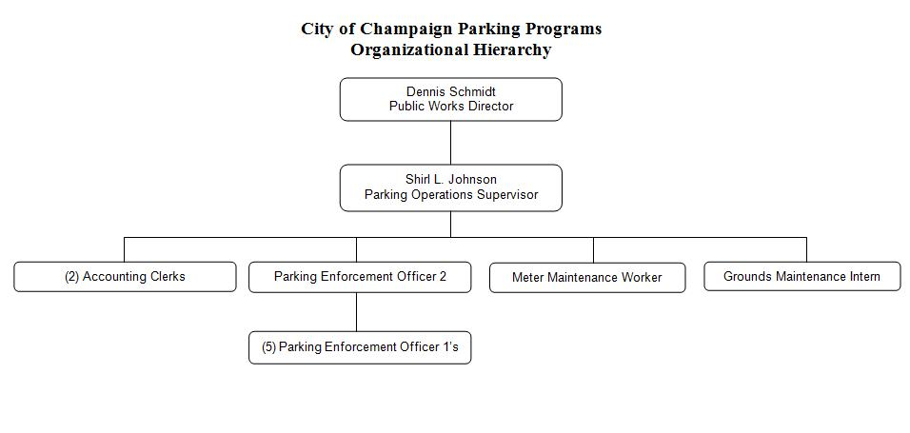
Exhibit 2
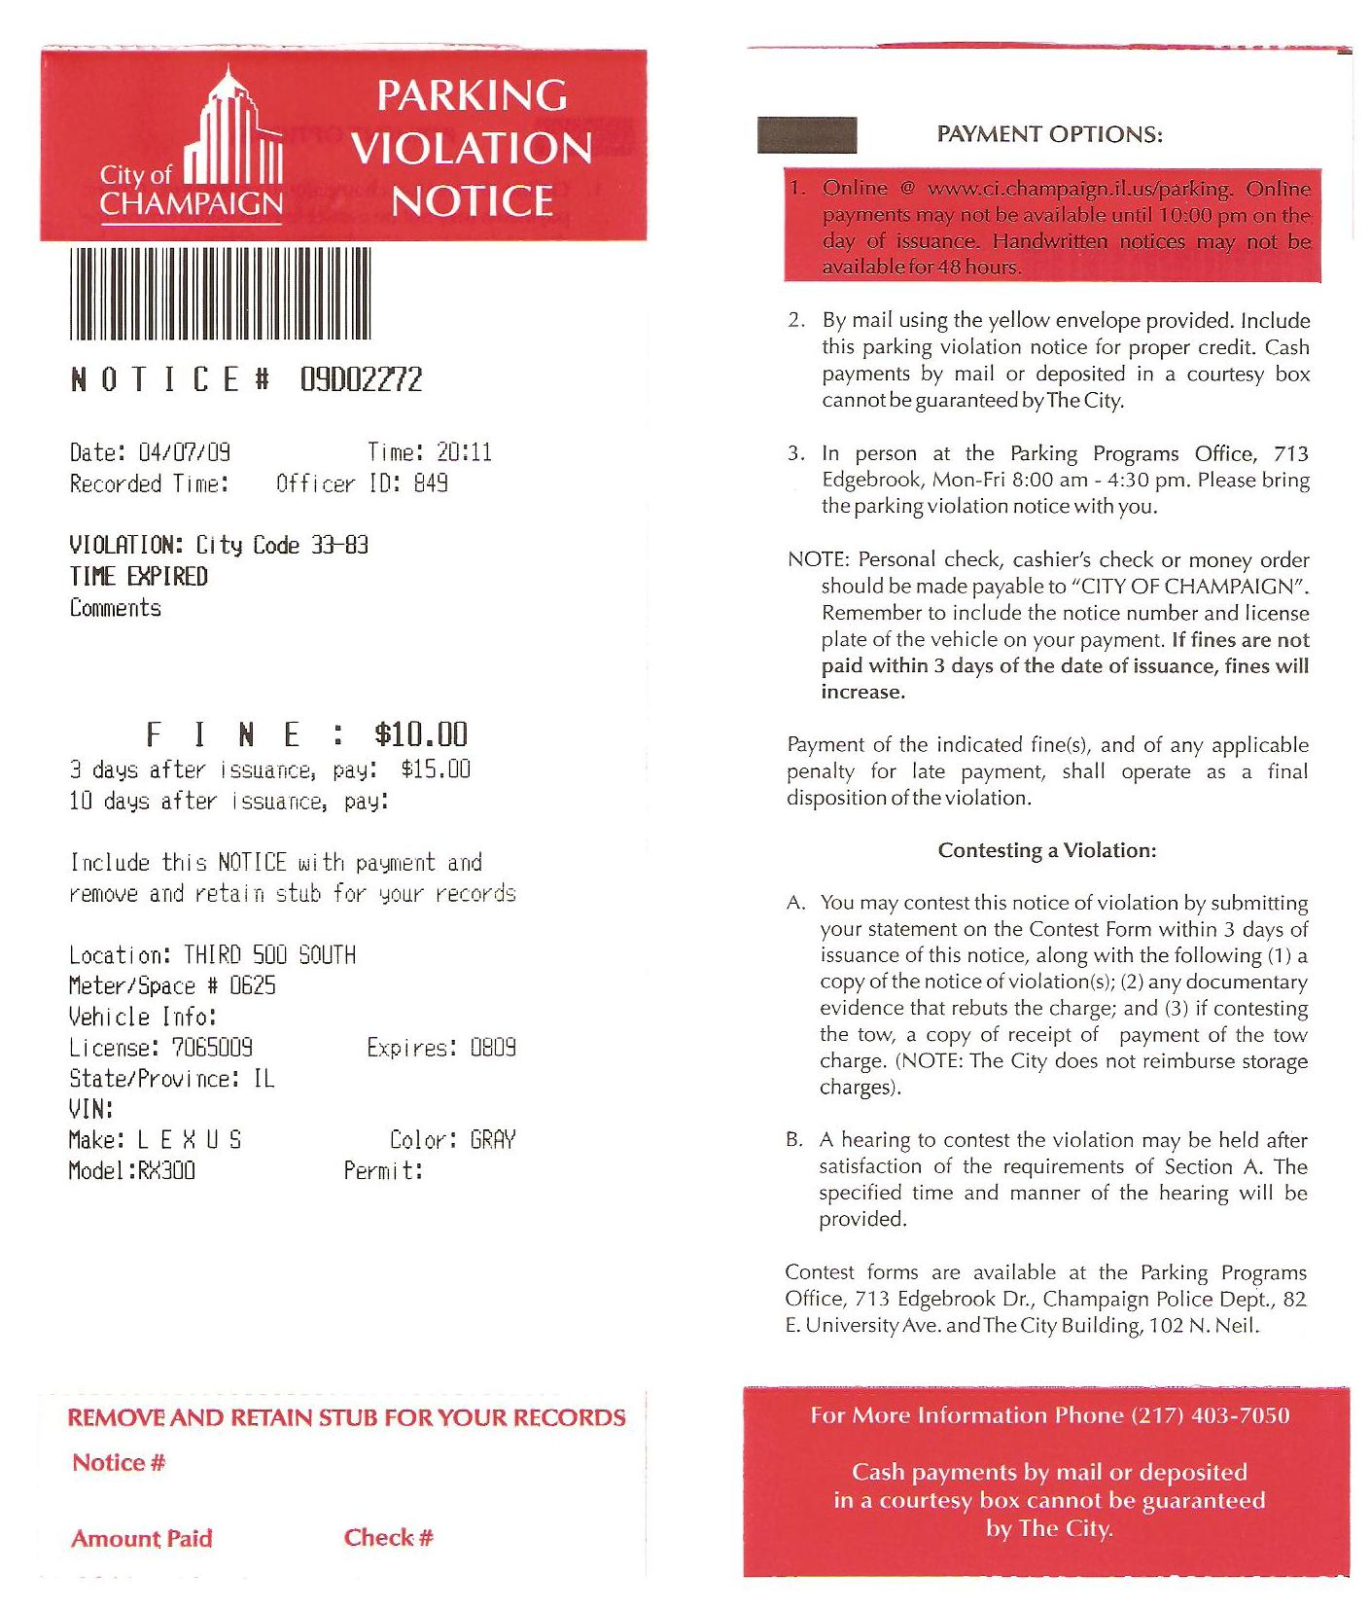

Eve Yanaki, an undergraduate student, prepared this case under the supervision of Professor Jasmijn Bol, University of Illinois at Urbana-Champaign, as the basis for class discussion rather than to illustrate either effective or ineffective handling of an administrative situation. All rights reserved, 2009.

